Hi Jason,  
See my below screenshots, I selected time frame as last 30 days and applied filter STORAGE.  
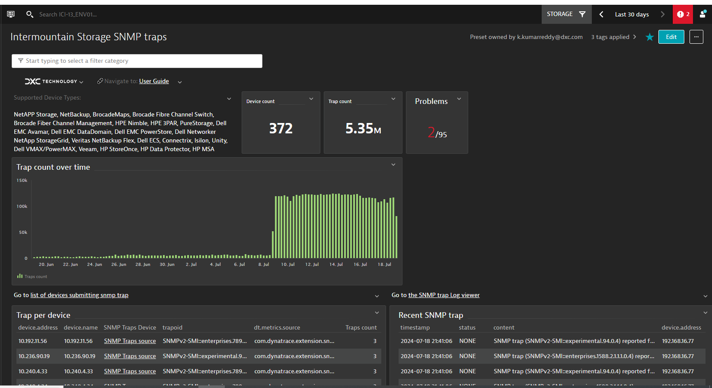

Go to 19th Page, there you can see 10.236.90.19 IP. I am seeing this is active but still showing IP in place of FQDN.

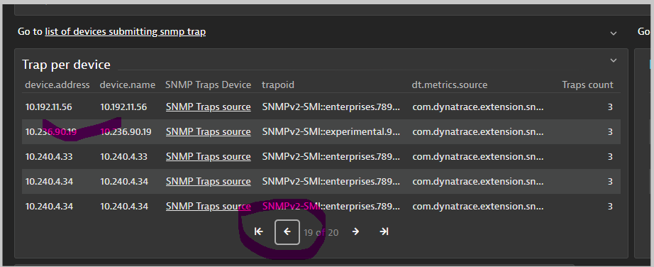

Here is the one with IP and one with FQDN but both are active.   
  
